# Power Bi Challenges:

## Q1 [Easy] - Find the right relationship

**Tags**: Relationship

#### Department can have multiple employees but employees can belong to only one department. So, the relationship between the “Employees” and the “Department” table will be **many _to one**

## Q2 [Medium] - Which JOIN is most suitable?

**Tags**: JOIN

For the tables visualized below, which kind of join will lead to the resultant table?

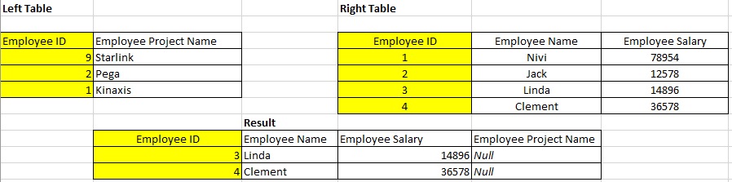

### Answer:

Here , in the above case, 2 separate joins were applied

* Step 1: **Right outer join** was applied. This returns the records in Right Table with all its records irrespective of whether if such Employee ID value is present in Left Table or not.
* Step 2: Further, the records were filtered with employee ID which were common in Left Table and Right Table.

## Q3 [Hard] - Based on Instruction #1 to #5

**Tags**: Data Transformation, Data Modeling, Slicer, Filter, Data Visualization, DAX

Refer to #Instruction Guide business case study to solve the rest of the questions.

Blu wants to analyze the transactions that have gross that are not negative. Further analysis is needed on a Deputy Manager level.

For a Deputy Managers named **Andrew Ma** and **Carlos Grilo,** what is the total sales in Millions?

### **Answer**:-

* For Deputy Manager Andrew Ma, the total sales are 0.61M and

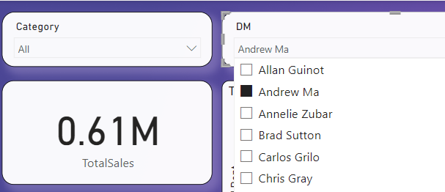

* For Deputy Manager Carlos Grilo, the total sales are 2.24M.

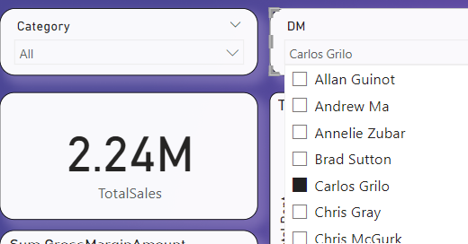

## Q4 [Hard] - Based on Instruction #1 to #5

**Tags**: Data Transformation, Data Modeling, Slicer, Filter, Data Visualization, DAX

Blu management is interested to know the highest total sales contribution in the top territory made by DMs **Andrew Ma** and **Carlos Grilo** jointly. What is the right answer?

### Answer:-

The highest total sales contribution in the top territory (VW) is 2.85 M ( Andrew Ma contribution is 0.61M and Carlos Grilo contribution is 2.24M)

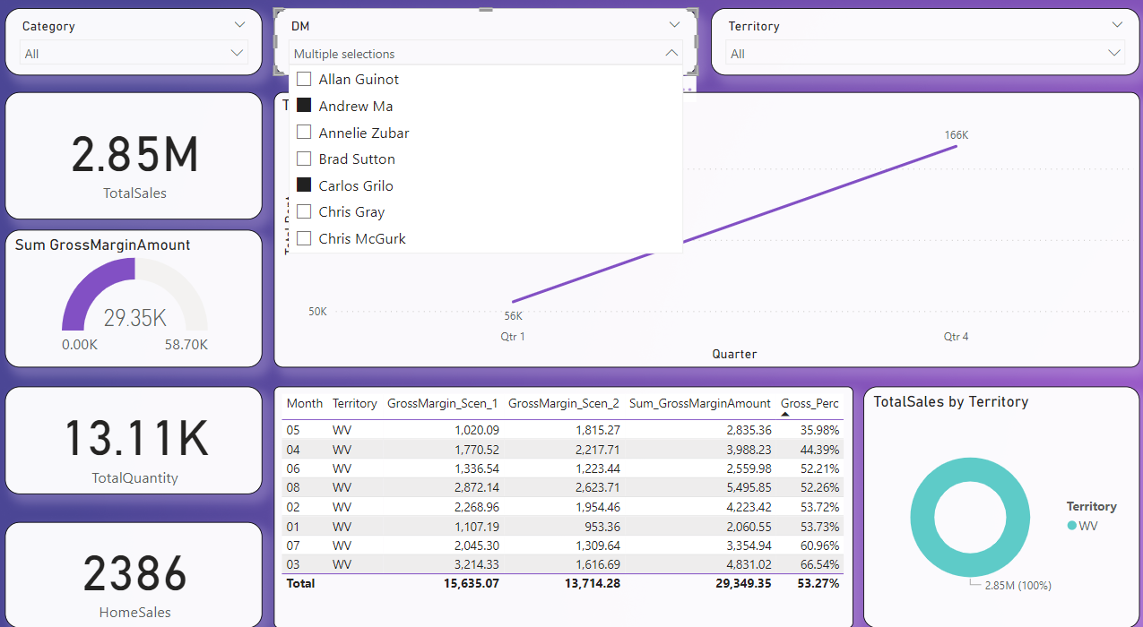

## Q5 [Medium] - Based on Instruction #6 to #7

**Tags**: Data Visualization, DAX, Data Formatting

To analyze the effect of probable loss of gross margins due to un-optimized inventory levels, Blue wants to know if there’s an immense need to maintain higher levels of Inventory. Maintaining higher levels of inventory can pose a serious risk to business due to piling up of unused stocks.

In the process, Management wants to know that out of total sales availed, what percentage sale is due to the **second highest territory** sum of sales. Also to make the inventory more robust, Management wants to target the strong zone for this territory. For which territory the sales are the second highest? Also Find the percentage contribution in sales due to this territory with respect to total sales. Analyze the highest sales year for this territory along with the strongest Non-Zero Quarter in it.

Answer: -

Point by point answer is given below:

* Management wants to know that out of total sales availed, what percentage sale is due to the **second highest territory** sum of sales.

**Answer:** As seen below, 22.22% is the percentage sale due to the second highest territory sum of sales (which is WV)

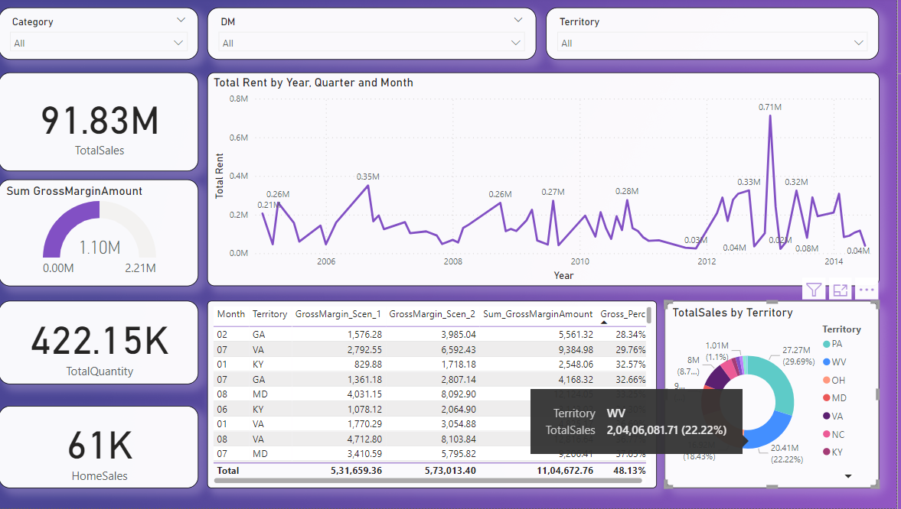

* Also to make the inventory more robust, Management wants to target the strong zone for this territory. For which territory, the sales are the second highest?

**Answer:** The territory with second highest sales is WV.

* Also Find the percentage contribution in sales due to this territory with respect to total sales.

**Answer:** As seen above, 22.22% is the percentage sale due to the second highest territory sum of sales (which is WV)

* Analyze the highest sales year for this territory along with the strongest Non-Zero Quarter in it.

**Answer:**

Highest Sale for territory WV is in the year 2010 (amount 93,30,887.86)

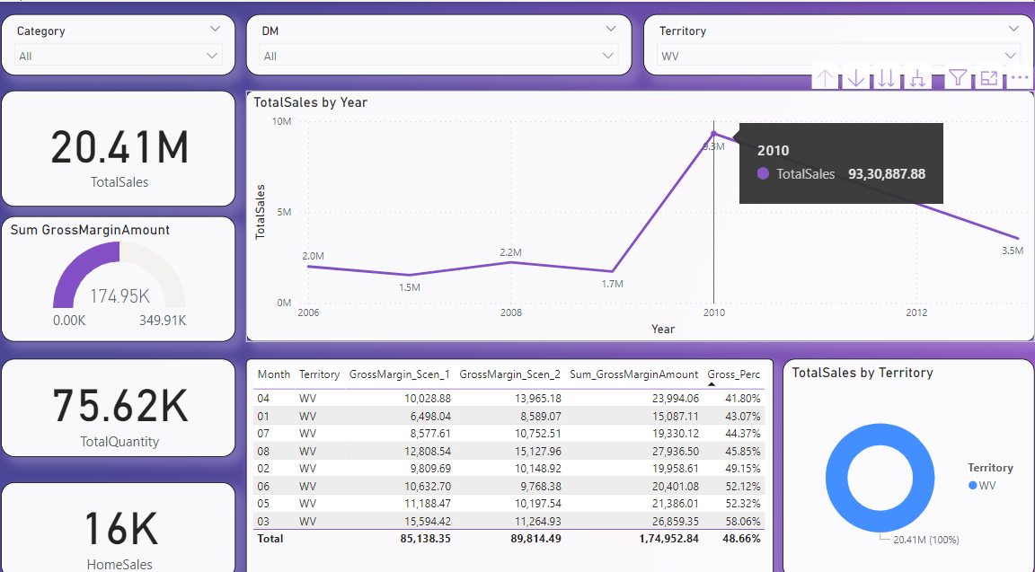

There are only 2 quarter with non-zero amount in the year for territory WV

1. Quarter 2 with total sales of 87,13,412.52
2. Quarter 3 with total sales of 15,17,475.36

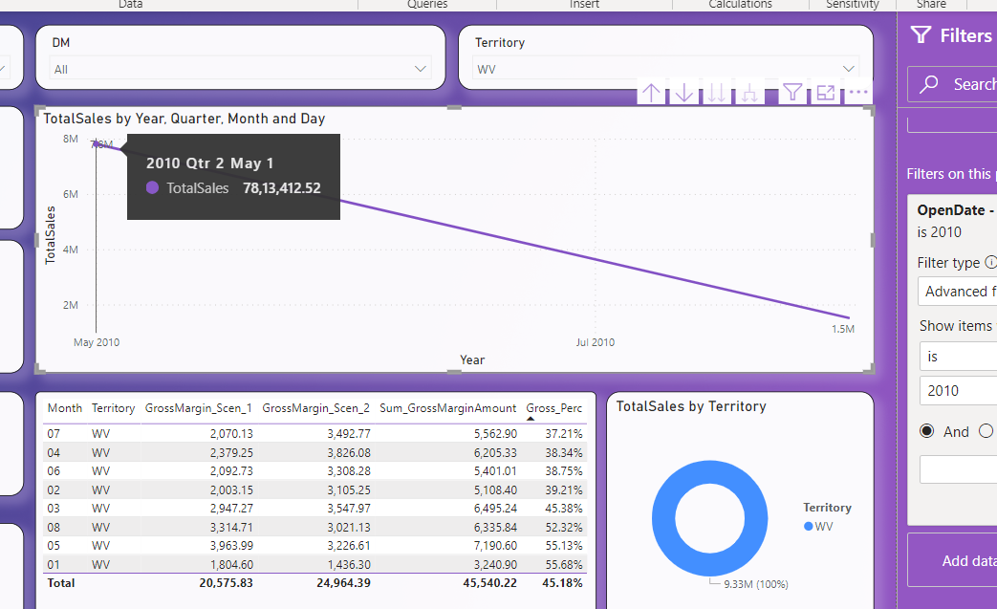

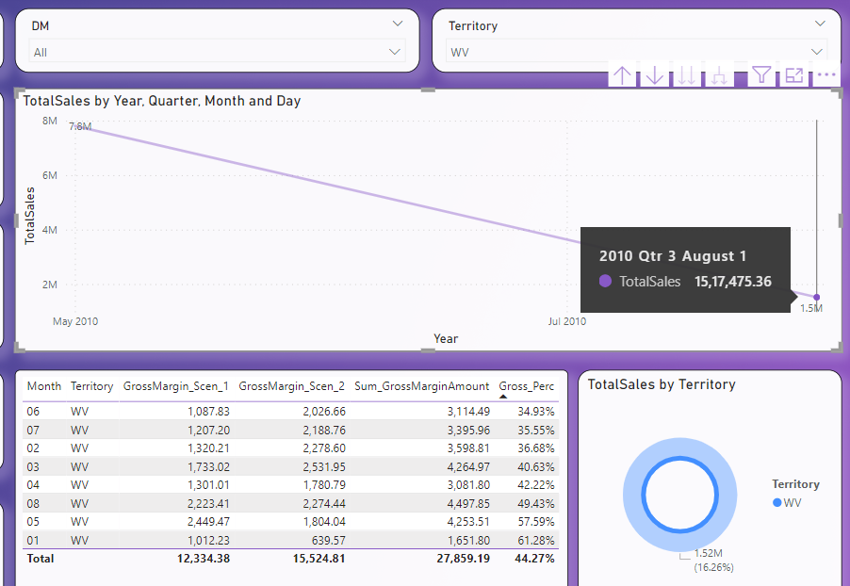

## Q6 [Easy] - After making the final dashboard

For the period years lower than 2011 during which stores have been opened, find out at which time (year, quarter, month) highest rent was generated and how much?

(Note - You’ve consider only the quarter and months which are in the year having the lowest rent and having atleast value greater than 0)

### Answer:

It may be noted that in the year 2007 (which is lower than year 2011), the lowest rent was recorded.

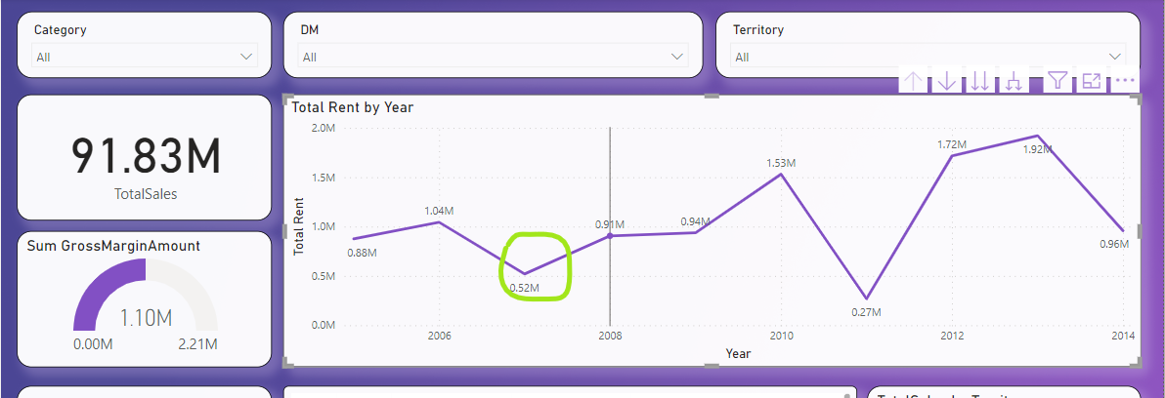

Now in the said year 2007, Qtr 2 has highest rent of amount 265788

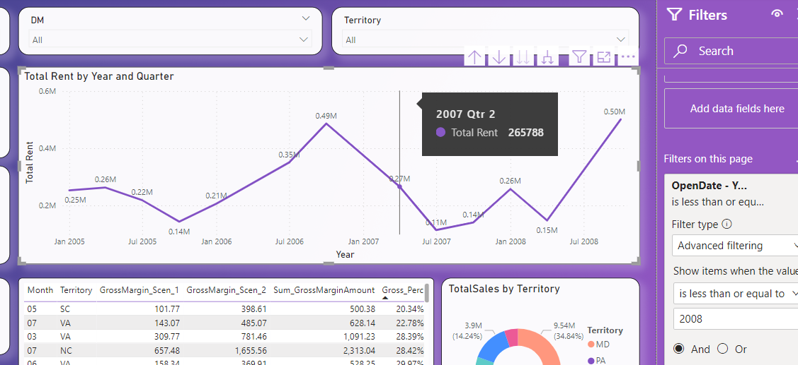

In the said quarter, April month has the highest rent received of amount 161545.

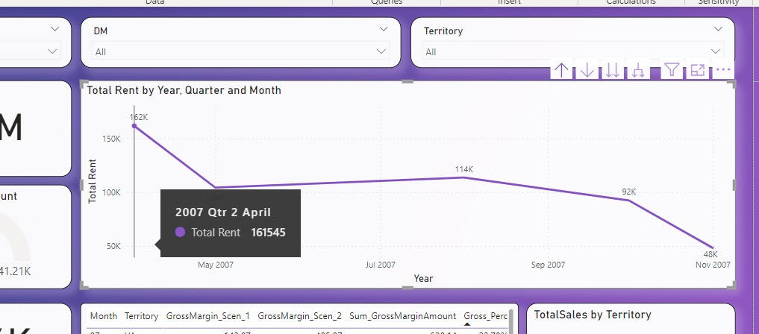

## Q7 [Easy] - After making the final dashboard

The global business head is always on the lookout to expand the business to various new industries in existing regions where penetration is low.

For territories TN,OH, MD, DE and GA, what is the total number of units sold and out of it, much is the units sold for the Shoes category ?

### Answer: -

|  |  |  |  |
| --- | --- | --- | --- |
| **S/N** | **Territory** | **Total no of units sold** | **Total units sold for Shoes Category** |
| 1 | TN | 7407 | 719 |
| 2 | OH | 107.70k | 5665 |
| 3 | MD | 33.74k | 2379 |
| 4 | DE | 4179 | 486 |
| 5 | GA | 10.08k | 1395 |

**TN:**

Total no of units sold

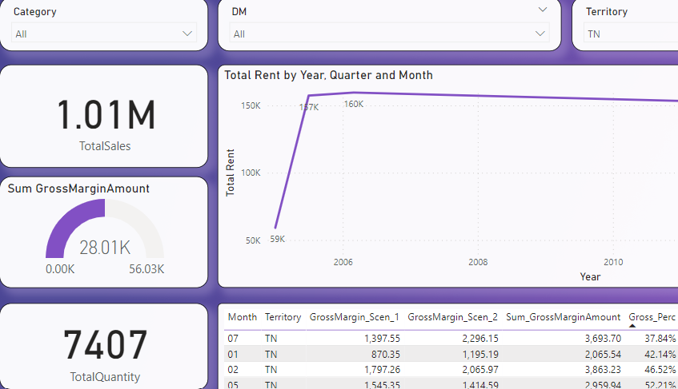

Total units sold for Shoes Category

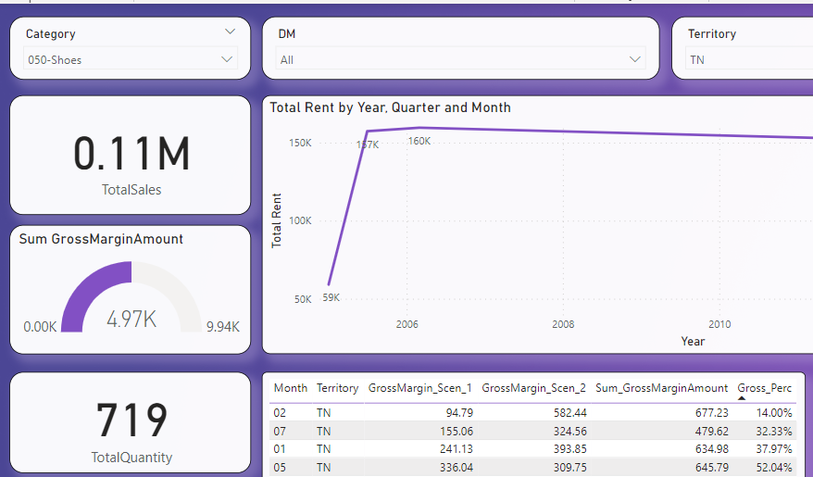

**OH**

Total no of units sold

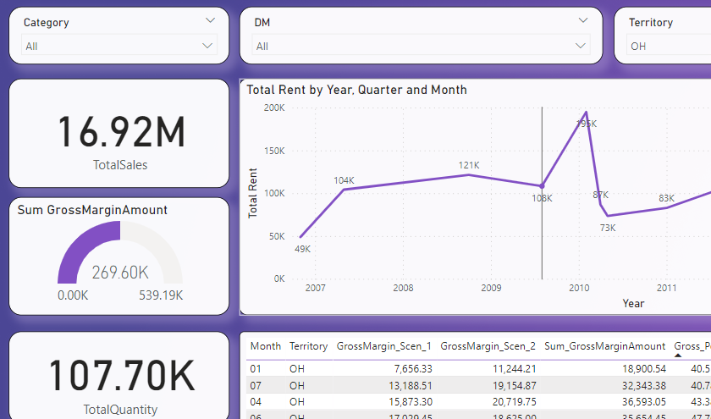

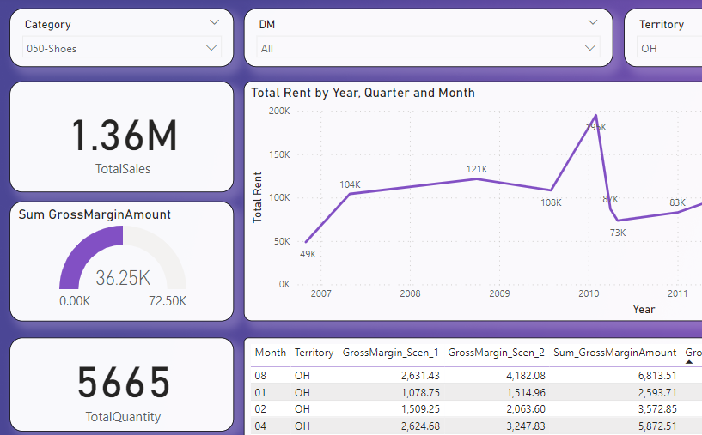

**MD**

Total no of units sold

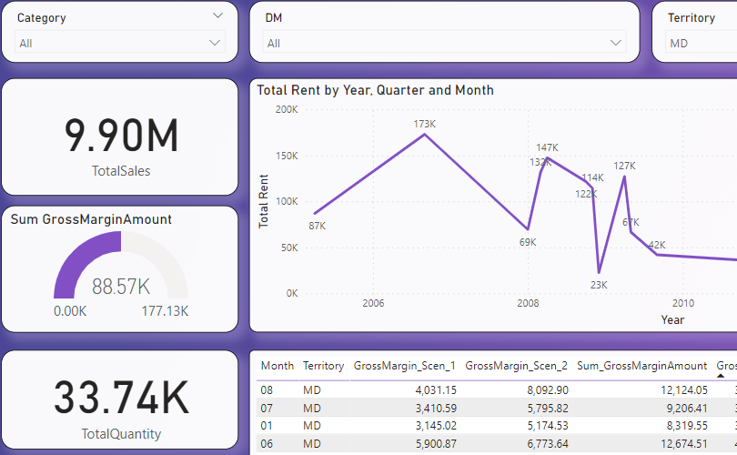

Total units sold for Shoes Category

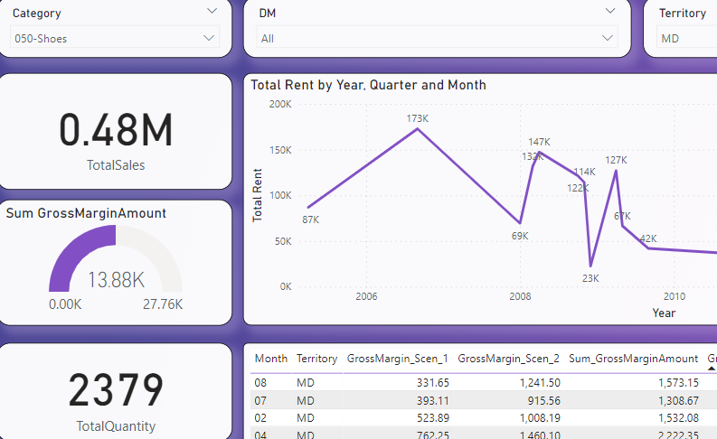

**GE**

Total no of units sold

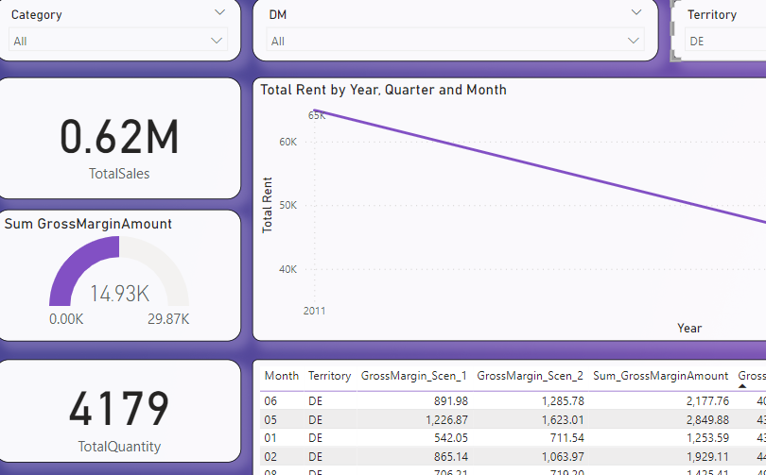

Total units sold for Shoes Category

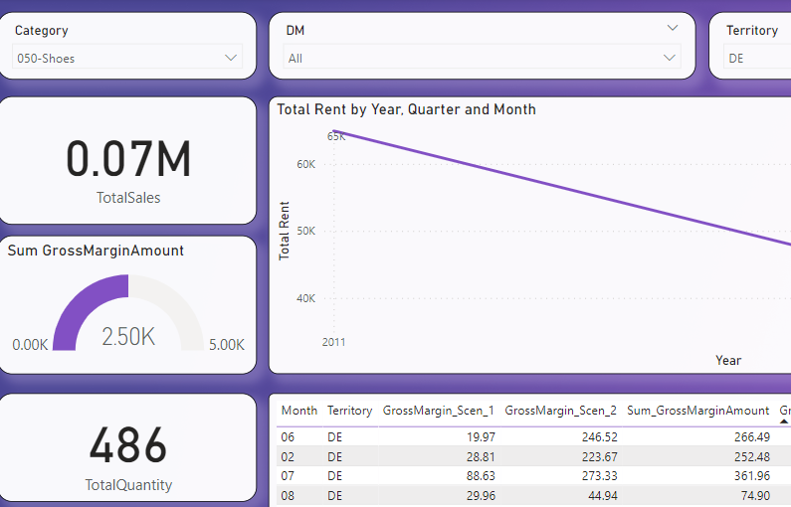  
  
**GA**

Total no of units sold

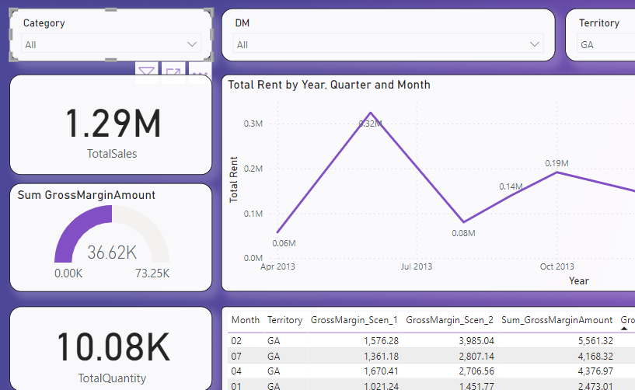

Total units sold for Shoes Category

